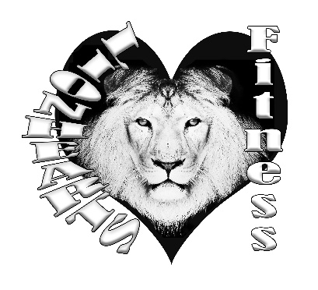
Lionhearts Fitness Camp!

Behavior Management

A caring and positive approach will be taken regarding discipline. Volunteer Camp Staff will reinforce appropriate behavior through positive reinforcement, firm statements and redirection of activity. In order to provide a safe and enjoyable play environment for all participants, Lionhearts Fitness reserves the right to dismiss any child from camp. In the event this occurs, all fees for the current session will be forfeited. We will follow the code of ethics as described in the Lionhearts Fitness Parent Handbook.

Basic Behavioral Norms:
1. Respect for camp counselors, fellow campers and property
2. Follow established camp rules
3. Follow the directions of Camp Counselors and be cooperative
4. Treat all equipment and supplies with proper care and respect
5. Running and excessive shouting while indoors is not allowed
6. Behavior that is threatening to the child or others will not be permitted at camp
7. NO vulgar language/conduct/bullying will be permitted
8. NO hostile or dangerous conduct will be permitted

Encouragement of Good Behavior
1. Creating fair choices and consequences for negative behavior and recognizing positive behavior.
2. Camper involvement in establishing camp rules.
3. Camp Counselors model a positive attitude, are consistent with discipline and engage with all campers.

In the event that Encouragement of Good Behavior is not effective, and the infraction is deemed more serious, Disciplinary Process will take place.

THE ONLY DISCIPLINARY ACTION IS : CALL PARENT!

If the case is severe enough to Coach ~shell , there is a possibility that only ONE offense will be tolerated, and parents immediately asked to pick up their child. For smaller infractions, we will contact the parents and ask them to intervene. Discipline belongs as home. If the behavior continues, we will discuss dismissal.

Examples of Serious/Extreme Offenses Which May Result In Dismissal from the Program
• Causing physical harm or threat to others or themselves • Physical or Verbal Assault •Stealing •Weapons, Drugs, Tobacco • Destruction of Property • Sexual Misconduct • Refusal to Cooperate •Leaving Designated Area • Excessive Temper Tantrums

I understand that inappropriate behavior will be recorded and tracked throughout the week. I have read and understand these policies and have explained them/read them to my child prior to the start of camp.

Parent or Guardian Signature: _______________________________________ Date:________________

