2019

Parent Welcome Packet

“The Lionhearts Fitness Program combines different sports and athletic methodologies to provide an environment that fosters excellence, allowing
participants to develop the self-discipline, integrity, confidence, character, courage, dedication, teamwork, and strong work ethic needed for future success.”

Summer 2019 Camp
“Carnival of Fitness”

Michele “shell” Luccketta, Victoria Phillips

Please encourage your child(ren) to participate in all activities, and ALWAYS listen to coach!

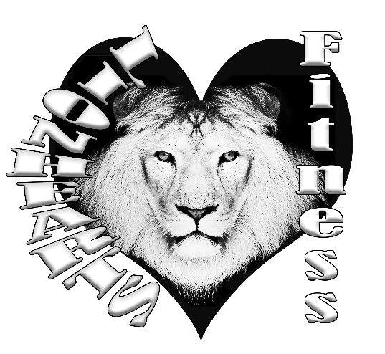

Table of Contents

Parent Information……………………………………pg. 3-4
Camp Agreement……………………………………..pg. 5
Liability Waiver/Minor Release Form ………………pg. 6
Pick-up Authorization List…………………………..pg. 6
Behavior Management………………………………..pg. 7

Money Talk & Registration

- All camp signups are available online as well as payments. Prices will vary based on duration of camp.
- Summer Camp is $110-$150 per participant, payable at LionheartsFitness.com Go to Sponsor a child - choose Summer Camp.
- We have scholarship programs for those in need.

- Be prepared for: providing healthy lunches & snacks, personal sporting equipment and other incidentals. We will do everything we can to make sure each child is included in all events.

Communication
We understand that parents deserve peace of mind once their children are left in the care of our coaches. Therefore, one of the most important aspects of our program is the
commitment to maintaining open communication between parents and staff. We want our
programs to be as accessible and transparent as possible. We welcome feedback. We can always improve our program and offer you and your child(ren) the best experience possible. Thank you for a wonderful opportunity to make a difference.

Daily Drop Off & Pick Up
The following procedures have been established to provide you and our coaches with the information needed to protect the health, safety, and well-being of your child while in our care:
- All youth must be picked up from camp NO LATER than 5 minutes after the end of camp. o $5 charge for every minute past pick up time arranged.
- Children will be signed in and out each day by their parent, guardian, or authorized adult. Photo ID must be presented.
- Unless prior written arrangements have been made only parents or parent representatives shown on the Pick-up Authorization List may pick up a child(ren).
- Drop off: 7:30a-9:30a
- Pick up: 4:30p-6p
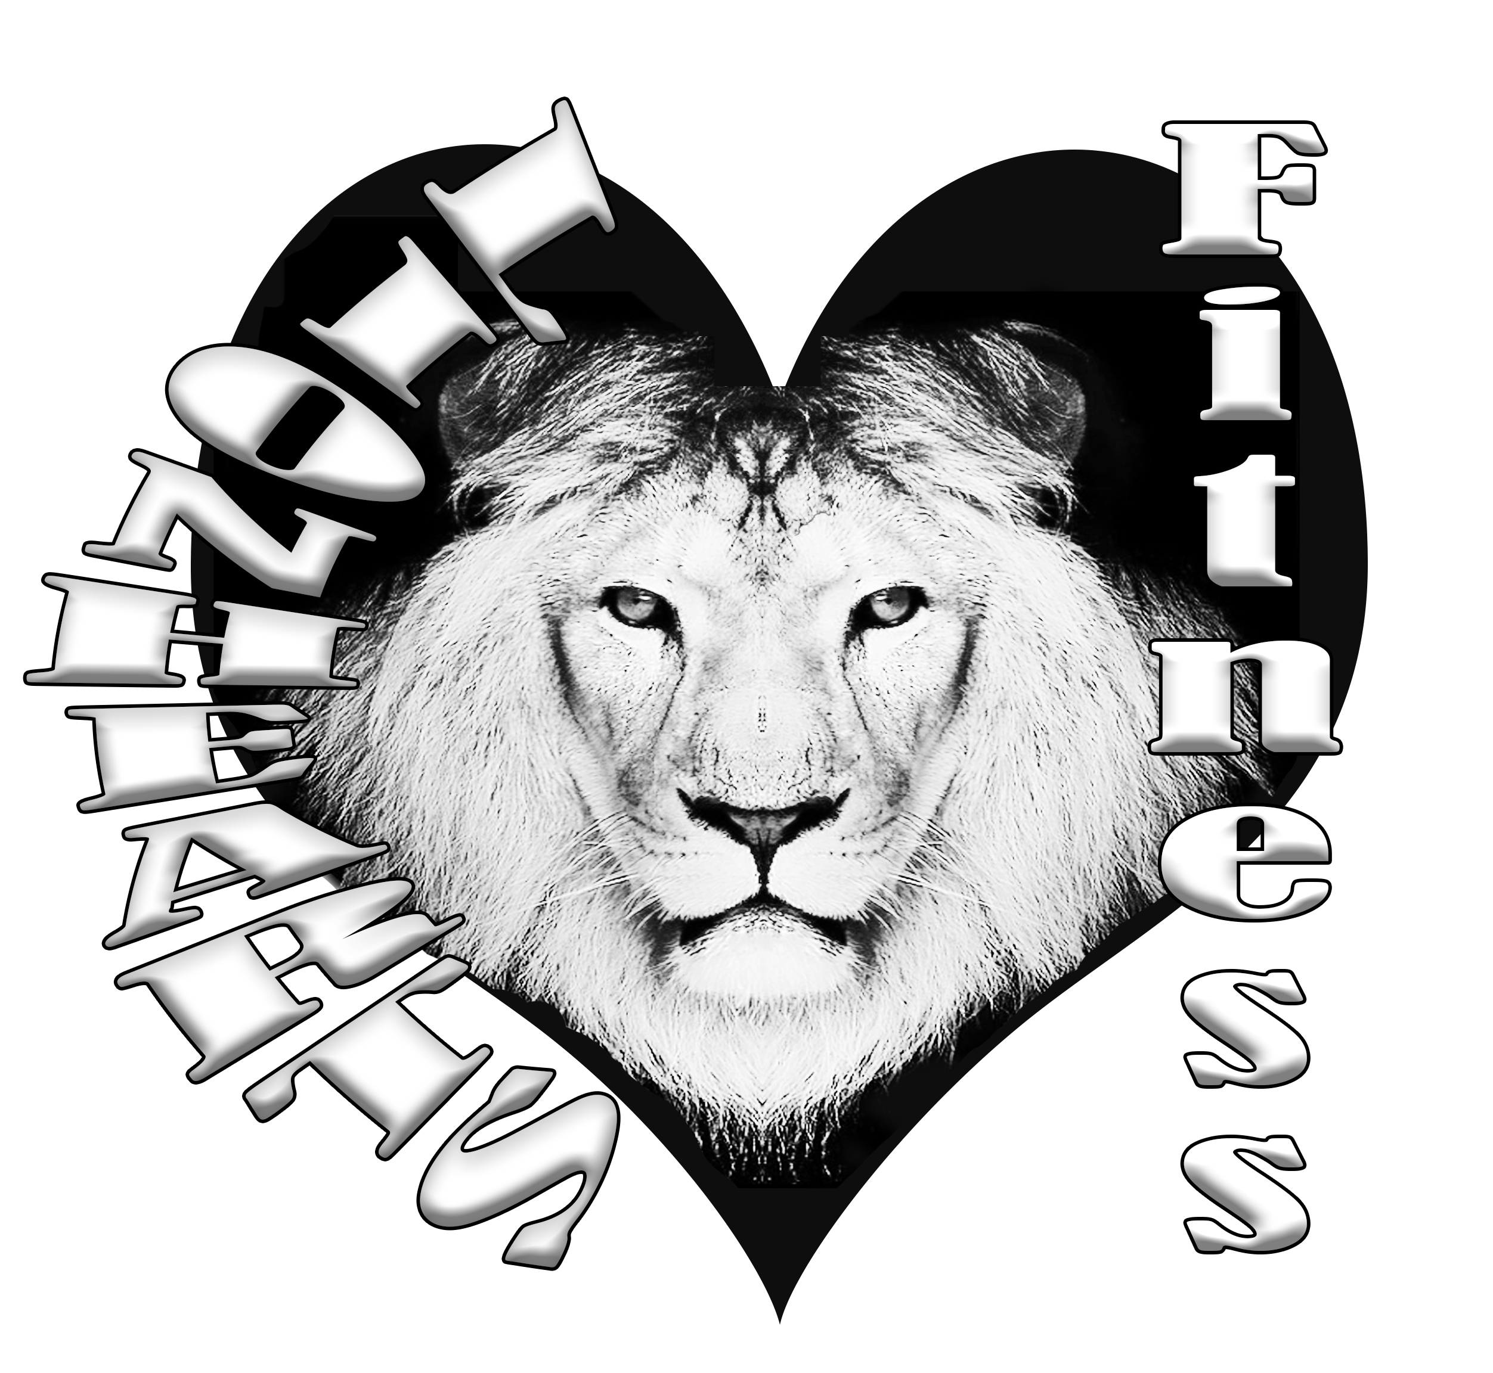

Dress Code
During camp and any Lionhearts activity, children should come appropriately dressed for the weather and daily sport activities. This will ensure their participation in all activities without restriction.
- Girls are encouraged to wear shorts, capri’s, or pants instead of dresses or skirts
- Participants are asked to wear socks and respective sport shoe (cleats) & sneakers
o Wrestling/boxing will be barefoot if you do not have wrestling shoes
- Proper protective gear is required per respective sport, provided by parents
- Clothing may not display inappropriate language, violence, or lewdness

Personal Belongings
There are no provisions to thoroughly safeguard personal belongings such as electronic equipment, video recorders, video games, toys, or other items of value. Bringing items of this nature to class is discouraged. The staff will work with the youth to ensure they learn to take responsibility for their personal items. All possessions (including lunch boxes, coolers, backpacks, balls, etc.) must be labeled in permanent marker with the child’s first and last name.

Things to Keep at Home
- Any items considered dangerous (knives, gun, weapons, fireworks, lighters, etc.)
- Money, jewelry, or any expensive articles
- Tablets and other electronic devices
- CELL PHONES: while at Lionhearts Fitness, your child will not be allowed to carry his or her cell phone on their person. All cell phones will stay in backpacks. They may check them at break times.

What to Bring to Camp
- Labeled Backpack
- Labeled Refillable Water bottle
- Labeled Change of clothes
- Labeled Sporting equipment (not required)
- Labeled Cooler with healthy lunch & two snacks

Discipline
Redirection, discussion, choices, and consequences are behavior modifications used when behavior requires disciplinary action. If these methods do not correct the behavior other actions such as suspension for various periods of time will be employed. Any act of physical violence towards anyone at all, will not be tolerated. Depending on the severity of the situation, immediate removal from the program may be warranted. Please see the detailed discipline policy in this handbook for further information and parent acknowledgment signature.

Infectious Disease/Illness
• Children with an infectious disease or severe illness will not be allowed to remain at class or to return to class until a note of medical release is received. In all emergencies, staff members /coaches will take reasonable measures to ensure the safety and welfare of participants. When illness merits greater care than the instructors can effectively provide without compromising the safety and health of other student, the parent, legal guardian, or other person authorized by the parent will be notified immediately to pick up the affected youth.

Forms Required Prior to the First Day of Class
- Online Registration
- Signed Liability Waiver
- Initialed & Signed Camp Agreement
- Pick-Up Authorization Form
- Child Information Form & Acknowledgement of Discipline Policy

Nutrition
- Parents are required to provide only HEALTHY food items.
- We will not allow campers to eat unhealthily, we will send the food item back home.
- Snack Time is tentatively at 10:00am and 3:00pm, this time will vary based on activities
- Lunch Time is tentatively at 12:00pm

Camp Agreement

Agreement between Parties: Carnival of Fitness Camps

Today the ___________ , The Individual(s)___________________________________________________ and the Lionhearts Fitness and Staff of Lionhearts Fitness and Youth OCR (hereafter referred to as Lionhearts Fitness,) agree to the following:

Parent/Guardian agrees to pay _________________ per child for the week of______________________ for ____________________________camp.

Preregistration, prepayment of fees, signed waiver and contract is required.
You may register day of, but all fees and papers must be filled out before your youth can participate.
Lionhearts Fitness agrees to provide Lionhearts Sports, Fitness, Conditioning, Education, and Coaching Services for each camper.

Description of Lionhearts Sports and Fitness Coaching: A partnership (defined as an alliance, not a legal business partnership) between Lionhearts Fitness and the parent/guardian. It is designed to facilitate the creation/development of athletic goals and to develop and carry out a strategy/plan for achieving those goals.
Lionhearts Fitness agrees to maintain the ethics and standards of behavior established by the Lionhearts Fitness Statement of Purpose and ethics (http://Lionhearts Fitness.com)
The parent/guardian is solely responsible for creating and implementing his/her own child’s physical, mental and emotional well-being, decisions, choices, and interactions with Lionhearts Fitness. As such, the parent/guardian agrees that the Lionhearts Fitness is not and will not be liable or responsible for any actions or inaction, or for any direct or indirect result of any services provided by the Lionhearts Fitness. The parent/guardian further acknowledges that he/she may terminate or discontinue the Lionhearts Fitness relationship at any time and is responsible to pay all monies due.

Applicable Law This Agreement shall be governed and construed in accordance with the laws of the State of Georgia, without giving effect to any conflicts of law’s provisions. Binding Effect This Agreement shall be binding upon the parties hereto and their respective successors and permissible assigns.

A liability MUST be signed in addition to this agreement for each participant, before receiving services.

Signature:_______________________ Date:________________
Print Name __________________________________________
Camper(s)____________________________________________
Lionhearts Fitness Office Only:
Representative: Signature________________________________Date______________

LIABILITY WAIVER AND RELEASE FORM (MINOR CHILD)

THIS IS A RELEASE OF LEGAL RIGHTS — READ AND UNDERSTAND BEFORE SIGNING

I hereby certify that I am the adult parent or guardian of _____________, a minor child under the age of eighteen years, and I consent to his/her participation in academic and/or athletic recreational activities with Lionhearts Fitness. I understand and acknowledge that I am fully aware of and assume the risks (including but not limited to the risk of serious bodily injury, property loss or damage) of (1) said minor child’s participation in activities with Lionhearts Fitness and (2) his/her use of the facilities. I recognize my responsibility to ensure that said minor child participates only in those activities for which he/she has the required skills, qualifications, training and physical conditioning. I understand that Lionhearts Fitness shall have no responsibility to pay for medical treatment and related costs if said minor child is injured. I agree, personally and on behalf of the minor child named above, to assume all the risks and responsibilities surrounding my minor child’s use of the facilities. To the fullest extent allowed by law, I hold harmless and agree to indemnify Lionhearts Fitness, its officers, directors, faculty, staff, volunteers, employees and agents, from and against any present or future claim, cause of action, loss or liability for injury to person or property, which said minor child may suffer or for which said minor child may be liable to any other person, related to said minor child’s participation in activities with Lionhearts Fitness, resulting from any cause whatsoever, and regardless of fault. I am at least eighteen years of age and have carefully read and freely signed this Liability Waiver and Release Form (Minor Child). I understand and agree that no oral or written representations can or will alter the contents of this document. I agree that this agreement shall be governed by the laws of the state of Tennessee (excluding its conflict of laws principles).
Please write very carefully, so we can best take care of your child/children.
Name: __________________________

Signed: __________________________ Date: ____________________

Pick-up Authorization

Only authorized persons may pick up any child/children. You must list your authorized responsible party below. You must contact us in writing to add or remove any party. We do this as a precautionary measure to protect your child/children from unauthorized pick up.
List Below:
1.
2.
3.

Behavior Management

A caring and positive approach will be taken regarding discipline. Camp staff will reinforce appropriate behavior through positive reinforcement, firm statements and redirection of activity. In order to provide a safe and enjoyable play environment for all participants, Lionhearts Fitness reserves the right to dismiss any child from camp. In the event this occurs, all fees for the current session will be forfeited. Expulsion may be for one day, a session, or the entire season/program depending upon the severity of the situation. We will follow the code of ethics as described in the Lionhearts Fitness Parent Handbook.

Basic Behavioral Norms:
1. Respect for camp counselors, fellow campers and property
2. Follow established camp rules
3. Follow the directions of Camp Counselors and be cooperative
4. Treat all equipment and supplies with proper care and respect
5. Running and excessive shouting while indoors is not allowed
6. Behavior that is threatening to the child or others will not be permitted at camp
7. NO vulgar language/conduct/bullying will be permitted
8. NO hostile or dangerous conduct will be permitted
Encouragement of Good Behavior
1. Creating fair choices and consequences for negative behavior and recognizing positive behavior.
2. Camper involvement in establishing camp rules.
3. Camp Counselors model a positive attitude, are consistent with discipline and engage with all campers.

In the event that Encouragement of Good Behavior is not effective and the infraction is deemed more serious, Disciplinary Process will take place.
If the case is severe enough to Coaches ~shell and Victoria, there is a possibility that only ONE offense will be tolerated and parents immediately asked to pick up their child. For smaller infractions, we will contact the parents and ask them to intervene. Discipline belongs as home. If the behavior continues, we will discuss dismissal.

Examples of Serious/Extreme Offenses Which May Result In Dismissal from the Program
• Causing physical harm or threat to others or themselves • Physical or Verbal Assault •Stealing •Weapons, Drugs, Tobacco • Destruction of Property • Sexual Misconduct • Refusal to Cooperate •Leaving Designated Area • Excessive Temper Tantrums

I understand that inappropriate behavior will be recorded and tracked throughout the week. I have read and understand these policies and have explained them/read them to my child prior to the start of camp.

Parent or Guardian Signature: _______________________________________ Date:________________

