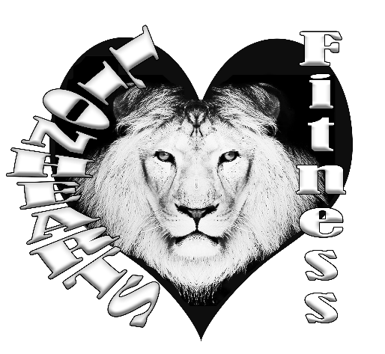
Coaches:
- Michele “shell” Luccketta
- Victoria Phillips
Itinerary:
- 7:15am Coaches Arrive
- 7:30am Campers Arrive
- 7:30am-8:00am Arts & Crafts/Greeting Time
- 8:30am Calisthenics & Lessons begin
- 1130am-12:30pm Lunch
- 4:30pm Lessons End & Open Play
- 6pm Last Pick-up

Monday: Get to know Camp Jordan & Lionhearts
7:30a-8:00am Orientation, name tag, water bottle
8:30am-9:00am Calisthenics
9:00am-11:30am Fitness Assessments
Lunch
12:30pm-4:30pm Get to Know Camp Jordan
Walk the Trail
Scavenger Hunt

Tuesday: Baseball & Soccer
8:30am-9:00am Calisthenics
9:00am-11:30am Baseball: Training and Conditioning
Lunch
1:00pm-2:00pm Soccer Footdrills
2:00pm-2:30pm Scrimmage
3:00pm-4:30pm Capture the Flag

Wednesday: Volleyball & Football
8:30am-9:00am Calisthenics
9:00am-11:30am Volleyball: Training and Conditioning
Lunch
1:00pm-2:00pm Football Skills
2:00pm-2:30pm Scrimmage Flag Football
3:00pm-4:30pm Capture the Flag

Thursday: Junior Olympic Day
8:30am-9:00am Calisthenics
9:00am-11:30am
Lunch
1:00pm-2:00pm
2:00pm-2:30pm
3:00pm-4:30pm Capture the Flag

Comprised of multiple teams competing against each other:
Long Jump
Hurdle Jump
High Jump
¼ Mile
Relay Race
Shot Put
Spear Throw
Bubble Wars with bubble guns
Podium Award Ceremony
Tug of War

Friday: Closing Ceremonies
8:30am-9:00am Calisthenics
9:00am-11:30am
Lunch
1:00pm-2:00pm
2:00pm-2:30pm
3:00pm-4:30pm Party!
Scrimmage ALL day! Baseball, Soccer, Volleyball, Football, Capture the Flag

All that sign up early will get a free water bottle

