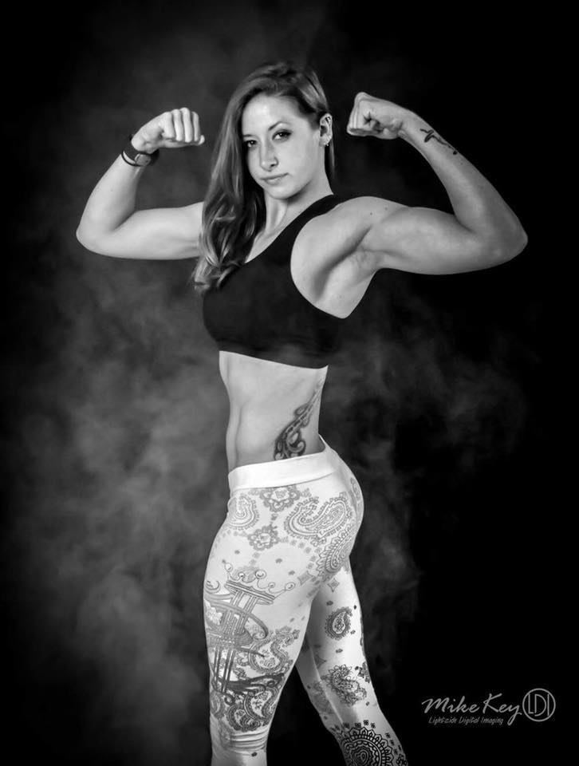
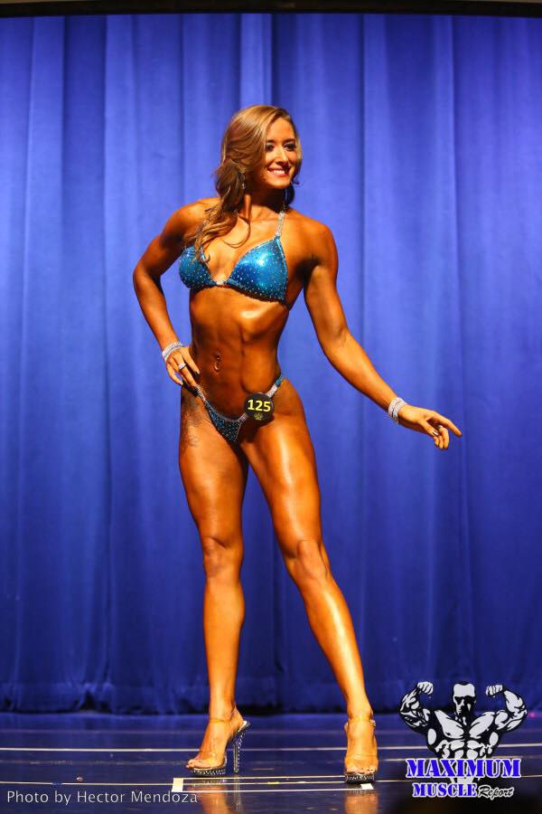
Victoria Phillips
Exercise Physiologist. Body Builder. Licensed Coach.

Phone number | 423-505-0072
Email | Victorifitness@gmail.com

Victoria Phillips | Youth Director, Coach, Motivator, Specialist
Victoria specializes in all day sports camps for elementary age athletes, focusing on the fundamentals of sports and functional movement through drills and games.
Victoria is a vital part of the Lionhearts development team. Her goal being: To bringing her vision, expertise and unbridled passion to the community.
Victoria is thrilled to become part of the already incredible “Our House Tribe.”
She says” Together, united, we shall build a youth program that accommodates all athletes from all levels of expertise.”

Professional certifications or licenses and Education | Victoria is an exercise physiologist and personal trainer and has been working as such since 2014.  She has a her ISSA, BA, NCCPT, Core Specialty, Dynamax, Mini Yogi's, and BLS certifications.
Body Building is her personal goal | A nationally qualified competitor in her first NPC competition. She plans to continue competing and dominating her fellow competitors.  Her ultimate goal in bodybuilding is to inspire others to push themselves past their expectations.  Victoria says, “Health and fitness is my lifestyle not just a job or a hobby. My mission is to impact and inspire as many people as possible! “

